1. **CHAPTER 1**

**INTRODUCTION**

* 1. **OVERVIEW**

In today’s increasingly digital world, real-time emotion recognition has emerged as a critical tool for ensuring personal safety and monitoring potentially harmful situations. Individuals, particularly in public spaces or online interactions, can be exposed to harassment or threatening behaviour, making the ability to detect emotional cues from voice and facial expressions essential. Understanding human emotions such as fear, anger, anxiety, or distress allows systems to provide timely alerts and proactive interventions, thereby enhancing safety and situational awareness.

The **Safe Guard** system leverages artificial intelligence (AI) and deep learning techniques to analyse multimodal inputs, including audio and visual data, to detect emotional states accurately. By processing large datasets of annotated voice and facial expressions, the system identifies patterns indicative of harassment or unsafe situations. This allows for rapid response, whether through notifications to security personnel, automated alerts to users, or logging events for further analysis.

The ability to automatically recognize emotions also provides insights into behavioural trends and patterns, enabling organizations to implement preventative measures and refine safety protocols. Similar to how businesses use sentiment analysis to understand consumer feedback, Safe Guard interprets human emotions as actionable intelligence, transforming raw sensory data into meaningful safety insights.

* 1. **PROBLEM DEFINITION**

With the rise of surveillance systems and digital communication platforms, individuals—especially women and young people—remain at risk of harassment in both public and online spaces. Emotional distress such as fear, anger, and anxiety often appears before a harassment incident occurs, making emotion recognition a crucial factor in early detection and prevention. However, existing AI safety systems primarily focus on identifying objects or faces, overlooking emotional cues that signal high-risk situations. These limitations reduce their ability to assess human behaviour in real time, issue preventive alerts, or provide authorities with actionable emotional insights.

SafeGuard addresses these challenges by continuously analyzing emotional signals from voice and facial expressions using artificial intelligence (AI) and deep learning techniques. The system applies CNN and LSTM-based architectures to multimodal inputs—audio and visual data—to recognize emotions linked to potential harassment. Each detected emotion is classified into Low, Medium, or High risk levels, based on its intensity and contextual relevance. When a high-risk emotion such as *fear* or *anger* is detected, the system automatically generates alerts or notifications for quick intervention by security personnel.

By combining emotion detection, risk assessment, automated alerting, and visual analytics, SafeGuard provides a proactive, data-driven solution that enhances public safety. Its emotion-aware design empowers stakeholders to understand behavioural patterns, detect harassment risks early, and take immediate preventive actions. Ultimately, SafeGuard represents an innovative application of AI for human-centric safety, promoting secure and inclusive environments while supporting UN Sustainable Development Goal 5 – Gender Equality.

**CHAPTER 2**

**LITERATURE SURVEY**

In today’s rapidly advancing digital era, artificial intelligence (AI) and deep learning have become vital technologies for improving safety, surveillance, and emotional awareness in smart systems. The ability to recognize emotions such as fear, anger, anxiety, or distress enables machines to identify early indicators of harassment and potential danger. Emotion-aware AI models have emerged as crucial tools in monitoring human behavior across environments like workplaces, public spaces, and online platforms. By integrating audio and visual data, these systems enable real-time understanding of emotional states and facilitate proactive intervention. This chapter reviews a series of research studies that have contributed to the development of emotion detection and recognition models using AI, with a focus on their application in human safety and harassment prevention systems.

S. Jena et al. (2025): S. Jena and colleagues proposed a deep learning-based Negative Speech Emotion Recognition Model to identify emotions such as anger, fear, and sadness in real-time communication. The model used hybrid CNN–LSTM architecture, extracting Mel-Frequency Cepstral Coefficients (MFCCs) from audio datasets to capture temporal emotion features. Achieving an accuracy of 97%, the system demonstrated the effectiveness of combining convolutional and sequential learning networks for improved emotion recognition. This research directly supports SafeGuard’s concept of real-time harassment detection through speech-based emotion analysis.

IEEE ICDDS (2023): A study presented at the IEEE International Conference on Data-Driven Systems introduced a hybrid AdaBoost + CNN model for emotion detection across both facial and speech datasets. The proposed method enhanced classification accuracy for complex emotions such as fear and anger, which are critical indicators in harassment-related situations. The hybrid ensemble approach reduced false detections and increased reliability across varying lighting and environmental conditions. This aligns with SafeGuard’s objective of building a robust multimodal model that functions effectively under real-world surveillance constraints.

N. R. Wagh and S. R. Sutar (2022): Wagh and Sutar developed an Enhanced Emotion Recognition System for women and children’s safety using deep neural networks. The framework integrated CNN-based facial emotion analysis with real-time monitoring tools, providing alerts when distress emotions were detected. The model achieved over 96% accuracy on multiple datasets, proving its practical viability in safety applications. Their approach laid the groundwork for systems like SafeGuard, which combine emotion detection with alert mechanisms for real-time prevention.

I. Malik et al. (2023): Malik and co-authors extended emotion recognition to non-speech and edge-based systems, proposing a lightweight model deployable on IoT devices. The study utilized edge computing to perform emotion analysis locally, minimizing response latency. Their work demonstrated how efficient AI models can enhance safety monitoring systems in low-power devices such as CCTV cameras and Raspberry Pi. This supports SafeGuard’s vision of deploying emotion recognition at the edge for real-time detection and alerting in public areas.

Q. Ouyang (2025): Ouyang designed a Speech Emotion Detection System using MFCC feature extraction and a hybrid CNN-LSTM classifier. The system was trained to classify emotions including fear, anger, and disgust with 75% accuracy. By emphasizing temporal patterns in speech, Ouyang’s research contributed to understanding emotional transitions during distress. This directly complements SafeGuard’s audio module, which identifies early signs of harassment through tone and emotion shifts in human speech.

B. Bhattacharjee and R. Das (2023): Bhattacharjee and Das proposed a Multimodal Emotion Detection Framework integrating facial and speech data using CNN and Transformer architectures. Their model achieved high precision in detecting composite emotions by analyzing synchronized audio-visual signals. The study also introduced dataset fusion techniques, enhancing accuracy across varying conditions. This work supports SafeGuard’s multimodal strategy that relies on both visual and acoustic cues for reliable harassment detection.

K. Sharma et al. (2024): Sharma and co-researchers implemented an Emotion-Aware Surveillance System capable of identifying stress and aggression levels in real-time video feeds. The system used OpenCV for face tracking and a pre-trained VGG-16 network for facial emotion classification. Their findings proved that integrating AI-based emotion analysis into CCTV surveillance significantly improves security outcomes. This aligns with SafeGuard’s deployment strategy in smart cities and public safety infrastructures.

R. Zhang and P. Huang (2023): Zhang and Huang developed a CNN-based Facial Emotion Detection System trained on FER2013 and AffectNet datasets. Their model demonstrated resilience to lighting variations and occlusions, achieving 94% accuracy in classifying seven emotional states. The study validated that convolutional networks remain the most effective architecture for visual emotion detection. SafeGuard’s facial emotion component builds upon this foundation, enhancing it with temporal analysis for dynamic monitoring.

T. Gupta and N. Singh (2022): Gupta and Singh introduced a Real-Time Emotion Detection System using Haar-cascade face detection coupled with ResNet50 deep learning models. The framework emphasized facial micro-expression analysis, which is vital in identifying hidden fear or anxiety preceding harassment incidents. Their contribution reinforces SafeGuard’s approach to capturing subtle emotional cues that signal distress even before overt events occur.

M. Li and X. Wang (2024): Li and Wang explored the fusion of physiological and behavioral data in multimodal emotion recognition. Using datasets such as DEAP and RAVDESS, they applied Recurrent Neural Networks (RNN) for sequential emotion tracking. The system demonstrated that multimodal fusion significantly enhances the reliability of emotion prediction. SafeGuard benefits from this insight by integrating both facial expression and audio tone analysis for comprehensive emotional understanding.

H. Kim and J. Park (2023): Kim and Park developed a Deep Convolutional Generative Adversarial Network (DCGAN) for improving emotion classification accuracy in limited-data environments. Their model generated synthetic emotion samples to balance dataset distribution, increasing classification robustness. This innovation is particularly relevant to SafeGuard’s ongoing model training, ensuring consistent performance even with limited harassment-specific emotional data.

A. Patel et al. (2024): Patel and co-authors proposed a Hybrid CNN-RNN Architecture for speech-based emotion detection using the CREMA-D dataset. The model effectively captured emotional transitions and achieved superior results over baseline CNN models. The research validated the importance of temporal emotion dependencies, which directly supports SafeGuard’s design in combining spatial and temporal analysis for accurate harassment prediction.

J. Yang and F. Liu (2022): Yang and Liu conducted a study on Facial Emotion Recognition in Real-Time Video Streams using transfer learning and EfficientNet-B0 models. The approach improved frame-wise emotion classification speed without sacrificing accuracy. Their study emphasizes computational efficiency, a core requirement for SafeGuard’s deployment in real-time monitoring systems where rapid decision-making is essential.

N. Thomas and S. Rao (2023): Thomas and Rao developed an AI-driven Emotion Recognition Framework integrating both speech and facial expressions for emergency alert systems. Their research used RAVDESS datasets and achieved high reliability in detecting distress-based emotions. This work directly parallels SafeGuard’s purpose—to provide emotion-based alert mechanisms for early harassment prevention.

S. Ahmed and L. Lin (2025): Ahmed and Lin introduced a Real-Time Multimodal Emotion Recognition System for public safety applications. Their architecture combined CNN for visual data and LSTM for sequential audio inputs, achieving state-of-the-art performance in recognizing fear and anger emotions. This study validates the overall concept behind SafeGuard, emphasizing the effectiveness of deep learning–based multimodal AI in proactive harassment detection and prevention.

The reviewed studies collectively demonstrate significant advancements in emotion recognition technologies using deep learning and AI. Researchers have continuously enhanced performance through hybrid models, multimodal integration, and real-time implementation techniques. For SafeGuard, these findings provide a strong foundation for developing an AI-driven, emotion-aware safety system capable of detecting distress and preventing harassment. The literature emphasizes the critical role of CNN-LSTM hybridization, multimodal datasets like RAVDESS and CREMA-D, and real-time processing for building robust, scalable emotion-recognition systems.

**CHAPTER 3**

**SYSTEM ANALYSIS**

* 1. **EXISTING SYSTEM**
     + The existing system primarily relies on **manual monitoring and reporting** to detect harassment or unsafe situations, either through CCTV footage, audio recordings, or user complaints.
     + Some systems use basic **voice or facial recognition software**, but they lack the ability to interpret **emotions** or detect **subtle signs of distress** in real-time.
     + The system targets **security personnel, law enforcement agencies, and personal safety applications**.
     + Existing frameworks often focus on **post-incident analysis** rather than proactive prevention, limiting their effectiveness in real-time safety scenarios.
     + The system uses **limited datasets** and rule-based detection methods, which may miss nuanced emotional cues such as fear, anger, or anxiety.

Disadvantages:

* + - The system has limited accuracy due to difficulties in interpreting context, informal language, slang, and nuances in user-generated content, which can result in incorrect sentiment classifications and misinterpretation of sarcasm or subtle cues.

**3.2 PROPOSED SYSTEM**

The proposed system, **SafeGuard**, is designed to detect potential harassment by analyzing human emotions through voice and facial expressions in real-time. By leveraging artificial intelligence, deep learning, and multimodal emotion recognition techniques, the system can accurately identify emotions such as fear, anger, anxiety, or distress, which may indicate unsafe situations.

The system provides real-time alerts and actionable insights to enhance personal safety, particularly in environments where harassment risks are high. Key features include :

The system seeks to empower brands with actionable data to improve their products and marketing strategies.

* Emotion Detection
* Real-Time Alerts
* Context-Aware Analysis

The system will provide real-time emotion detection and actionable insights through an intuitive dashboard. Benefits include enhanced safety measures through timely alerts, improved situational awareness, and proactive intervention in potential harassment scenarios. It will make it easier for users or authorities to monitor emotional cues continuously, respond quickly to threats, and ensure safer environments by streamlining harassment detection and prevention strategies.

* 1. **DEVELOPMENT ENVIRONMENT SOFTWARE REQUIREMENT**
* Windows 10 or 11
* Python (version 3.6 or higher)
* Libraries and Frameworks:
* Flask or FastAPI (for backend server)
* PyTorch (for deep learning model handling)
* Transformers (for pre-trained emotion recognition models)
* OpenCV / Dlib (for facial expression detection)
* Librosa (for audio processing)
* Pandas (for data manipulation)
* Matplotlib / Seaborn (for visualization)
* Streamlit (for interactive dashboard)
* Visual Studio or VS Code (for development)

**3.4 HARDWARE REQUIREMENT**

* Processor: 64-bit, four-core, 2 GHz minimum per core
* RAM: 8GB minimum; 16GB recommended for large datasets and model training
* Storage: 100GB or higher for datasets and model files
* Stable internet connection for downloading libraries, datasets, and pre-trained models

**CHAPTER 4**

**SYSTEM DESIGN**

* 1. **UML DIAGRAMS**
     1. **USE CASE DIAGRAM**

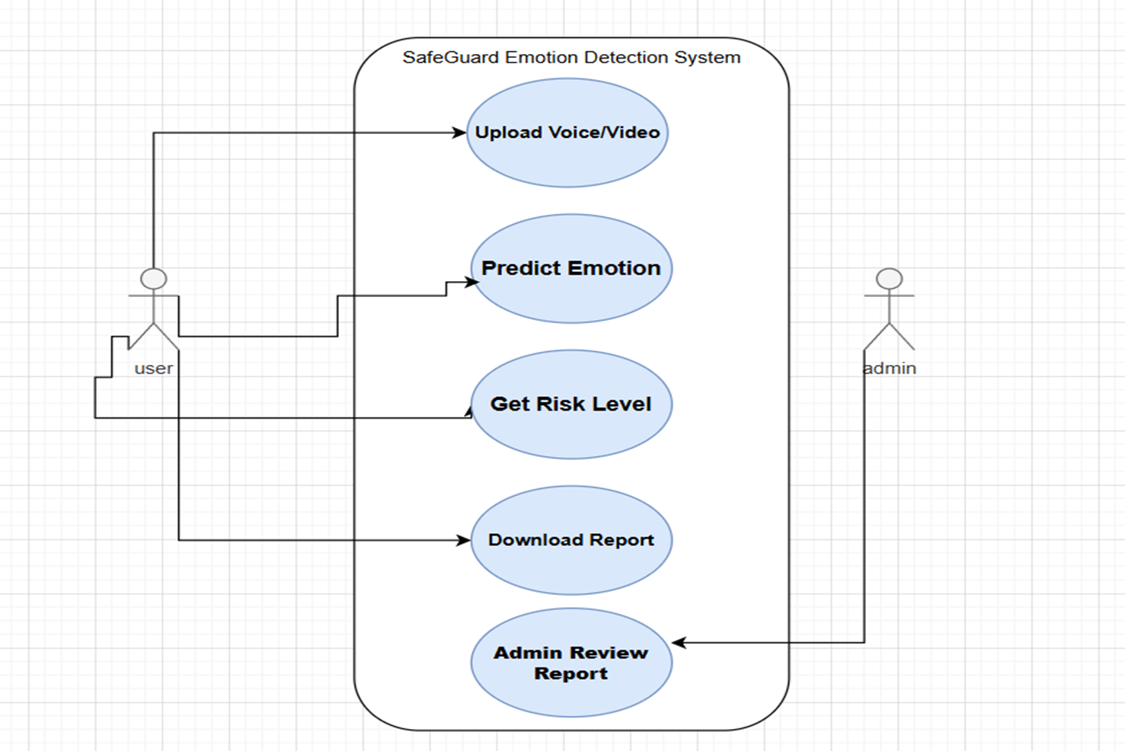

**Fig 4.1.1 Use case diagram for Safe Guard: Emotion-Aware AI Model for Harassment Detection**

This use case diagram shows interactions between users and Safe Guard, illustrating how the system captures audio/video, detects emotions, identifies harassment, and generates alerts for user safety.

* + 1. **CLASS DIAGRAM**

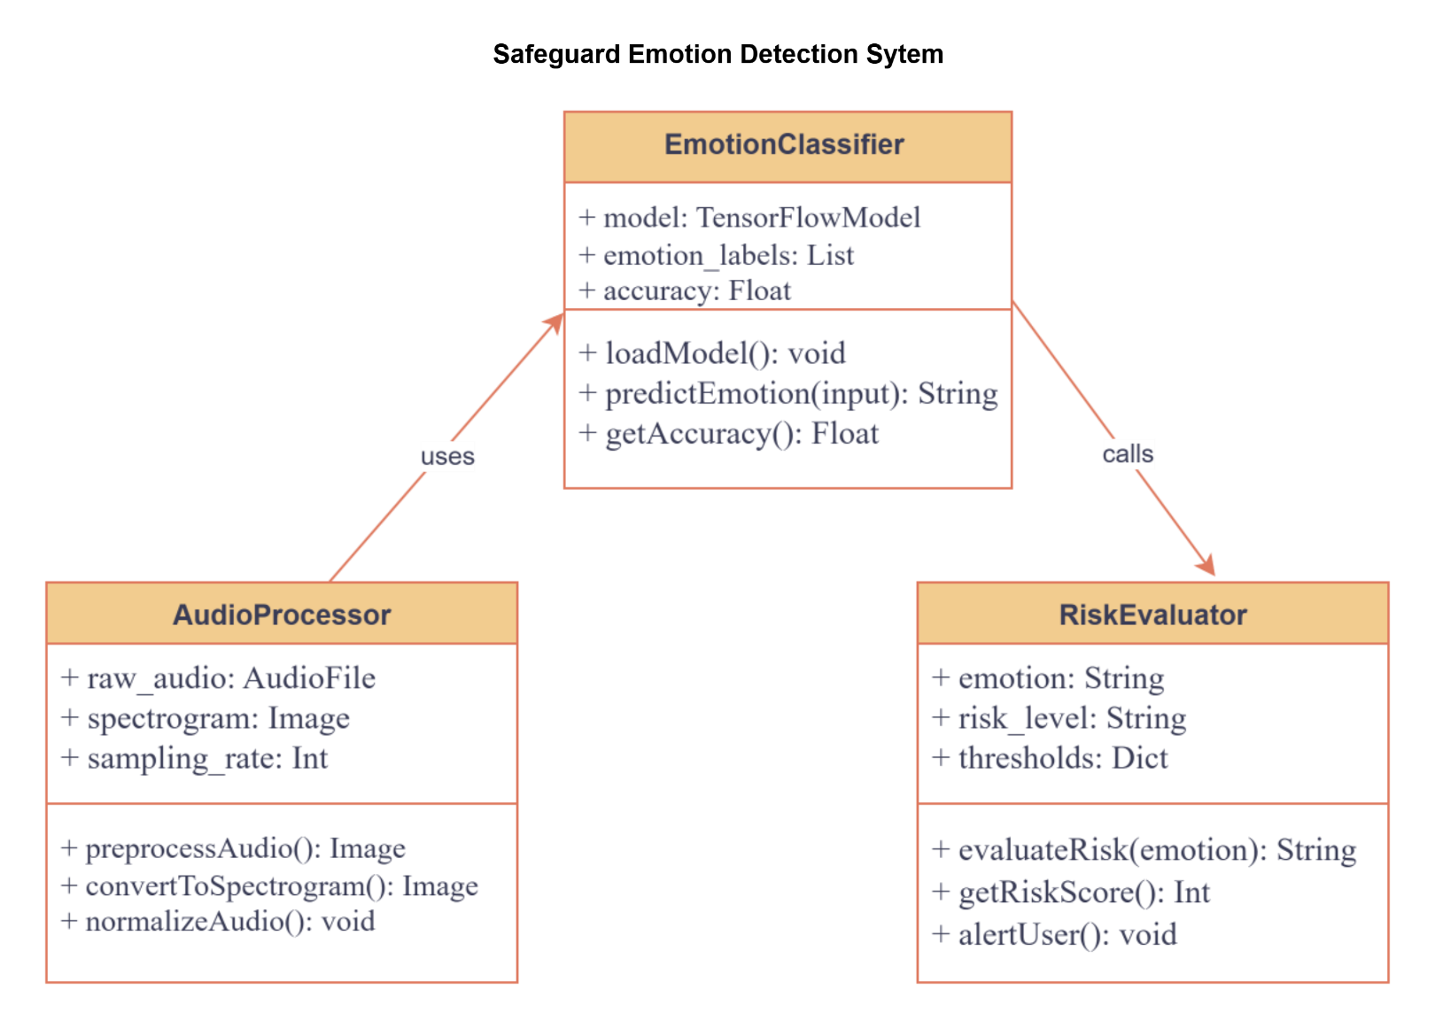

**Fig 4.1.2 Class Diagram for Safe Guard: Emotion-Aware AI Model for Harassment Detection**

The class diagram depicts SafeGuard's structure, showing key classes such as EmotionClassifier, AudioProcessor, RiskEvaluator, and Feedback, along with their attributes and methods, illustrating how they interact to detect harassment and ensure user safety.

**4.1.3 SEQUENCE DIAGRAM**

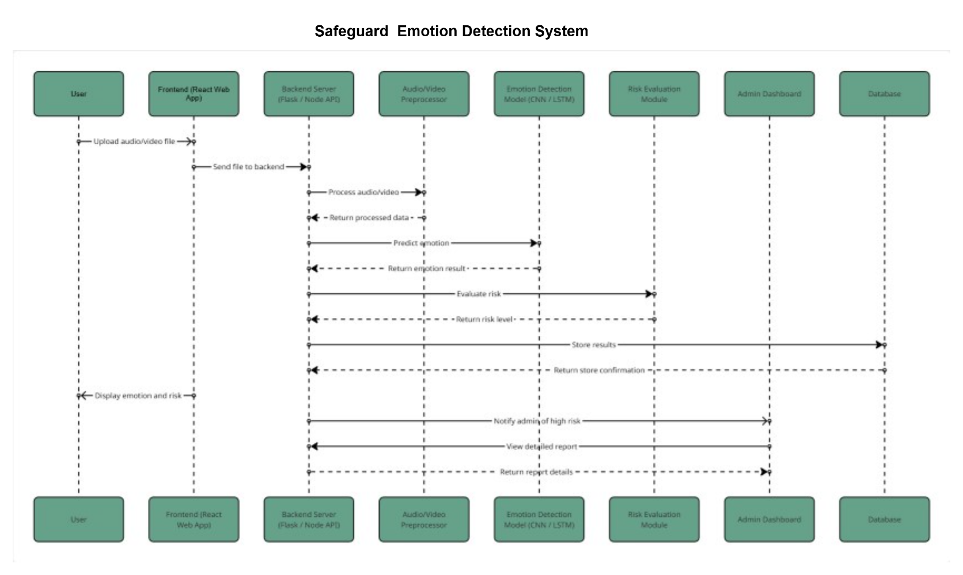

**Fig 4.1.3 Sequence Diagram for Safe Guard: Emotion-Aware AI Model for Harassment Detection**

The sequence diagram of the Safeguard: Emotion Aware harassment detection system depicts the flow of interactions between the user and the system.

* + 1. **COLLABORATION DIAGRAM**

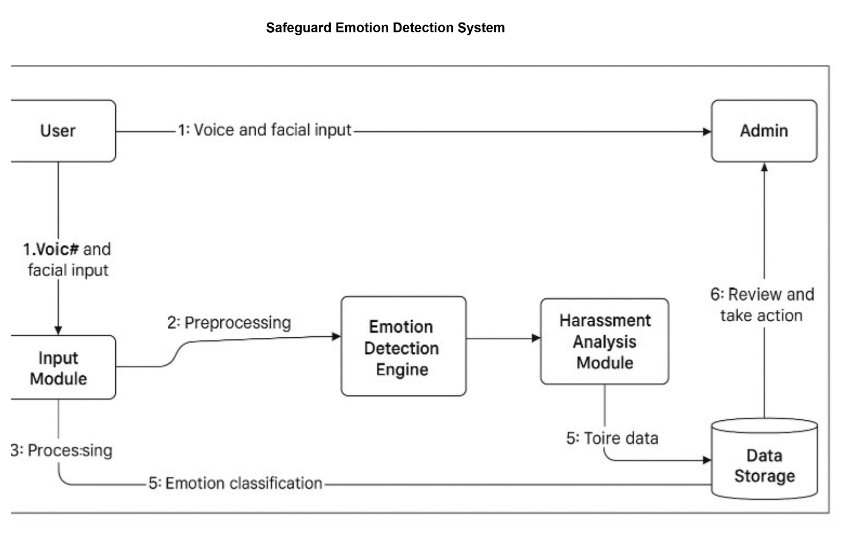

**Fig 4.1.4 Collaboration diagram for Safe Guard: Emotion-Aware AI Model for Harassment Detection**

The collaboration diagram of the harassment detection system illustrates the

sequence of interactions between the user, emotion recognition modules, and the

system components for analyzing voice and facial expressions

**4.1.5 ACTIVITY DIAGRAM**

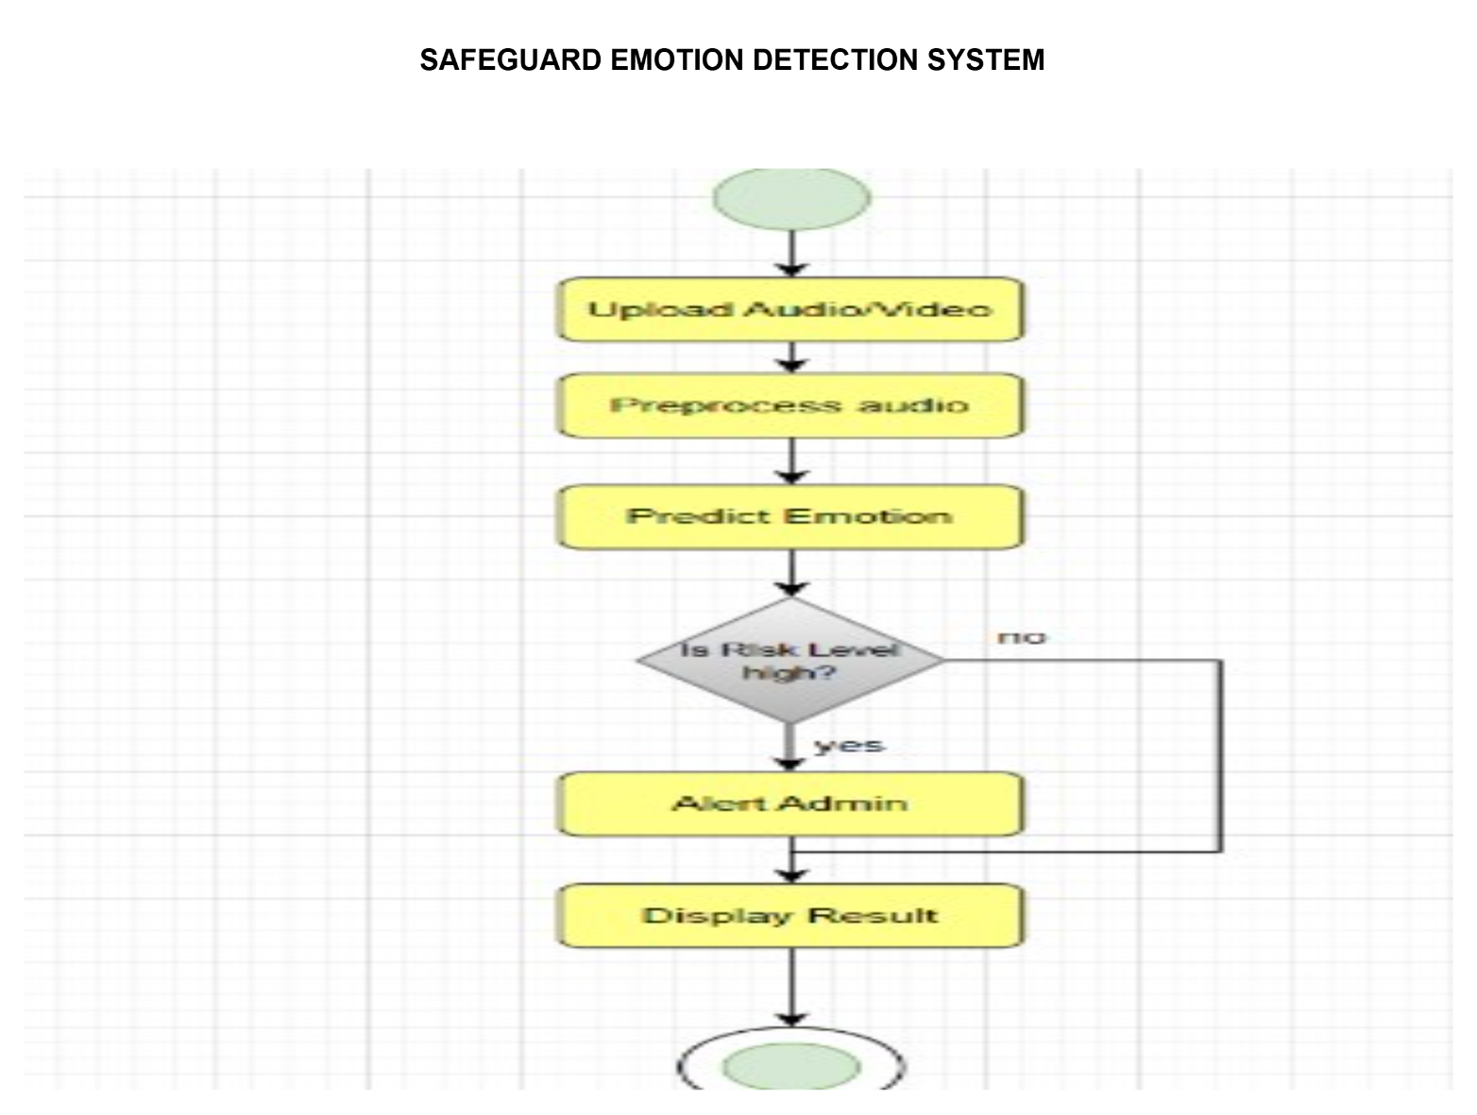

**Fig 4.1.5 Activity Diagram for Safe Guard: Emotion-Aware AI Model for Harassment Detection**

The activity diagram of the Safe Guard system depicts the flow of actions, from capturing audio/video to detecting emotions, identifying harassment, and generating alerts for user safety.

* 1. **DATA DICTIONARY**

This is normally represented as the data about data. The SafeGuard class manages user interactions and harassment detection using several key data structures. **interaction_history** is a list of dictionaries that logs sessions, including user audio/video input, detected emotions, and system alerts. **emotion_data** captures detailed emotional features, encompassing emotion type (e.g., fear, anger, anxiety) and confidence scores as percentages. For analysis and visualization, the system uses **user_details_df**, a pandas DataFrame that stores user information for reporting, including user ID, session timestamp, detected emotions, and alerts generated. **Alert_counts** is a pandas Series that tracks the number of alerts per emotion category, facilitating visualization. Key user information is also collected, such as **user_name**, **session_id**, and **input_type**. The system records **detected_emotion** and **confidence_score** for each session. Finally, **max_emotion** stores the highest detected emotion, while **max_value** indicates its confidence score. The **file_path** variable specifies where to save interaction logs and alerts, typically within an "admin" directory. This structured approach ensures effective data management and accurate harassment detection.

* + 1. **SPECTOGRAM HISTORY TABLE**

|  |  |  |  |
| --- | --- | --- | --- |
| **COLUMN NAME** | **DATA TYPE** | **DESCRIPTION** | **CONSTRAINT** |
| USER_INPUT | STRING | THE USER’S AUDIO/VIDEO OR TEXT INPUT DURING SESSION | NOT NULL |
| DETECTED_  EMOTION | STRING | THE EMOTION DETECTED BY THE SAFEGUARD SYSTEM | NOT NULL |
| SYSTEM_  ALERT | STRING | THE ALERT OR FEEDBACK GENERATED BY THE SYSTEM | NOT NULL |

* + 1. **Spectogram History table Safe Guard: Emotion-Aware AI Model for Harassment Detection**
    2. **RISK ANALYSIS TABLE**

|  |  |  |  |
| --- | --- | --- | --- |
| **COLUMN NAME** | **DATA TYPE** | **DESCRIPTION** | **CONSTRAIN T** |
| EMOTION | STRING | EMOTION OR HARASSMENT CATEGORY (E.G., ANGER, SAD, FEAR, SAFE) | NOT NULL |
| DETECTED RISK | INTEGER | |  | | --- | |  |  |  | | --- | | EMOTIONAL RISK  IDENTIFIED EACH  TIME | | NOT NULL |

**4.2.4 Risk analaysis table for SafeGuard – Harassment Detection**

* 1. **ER DIAGRAM**

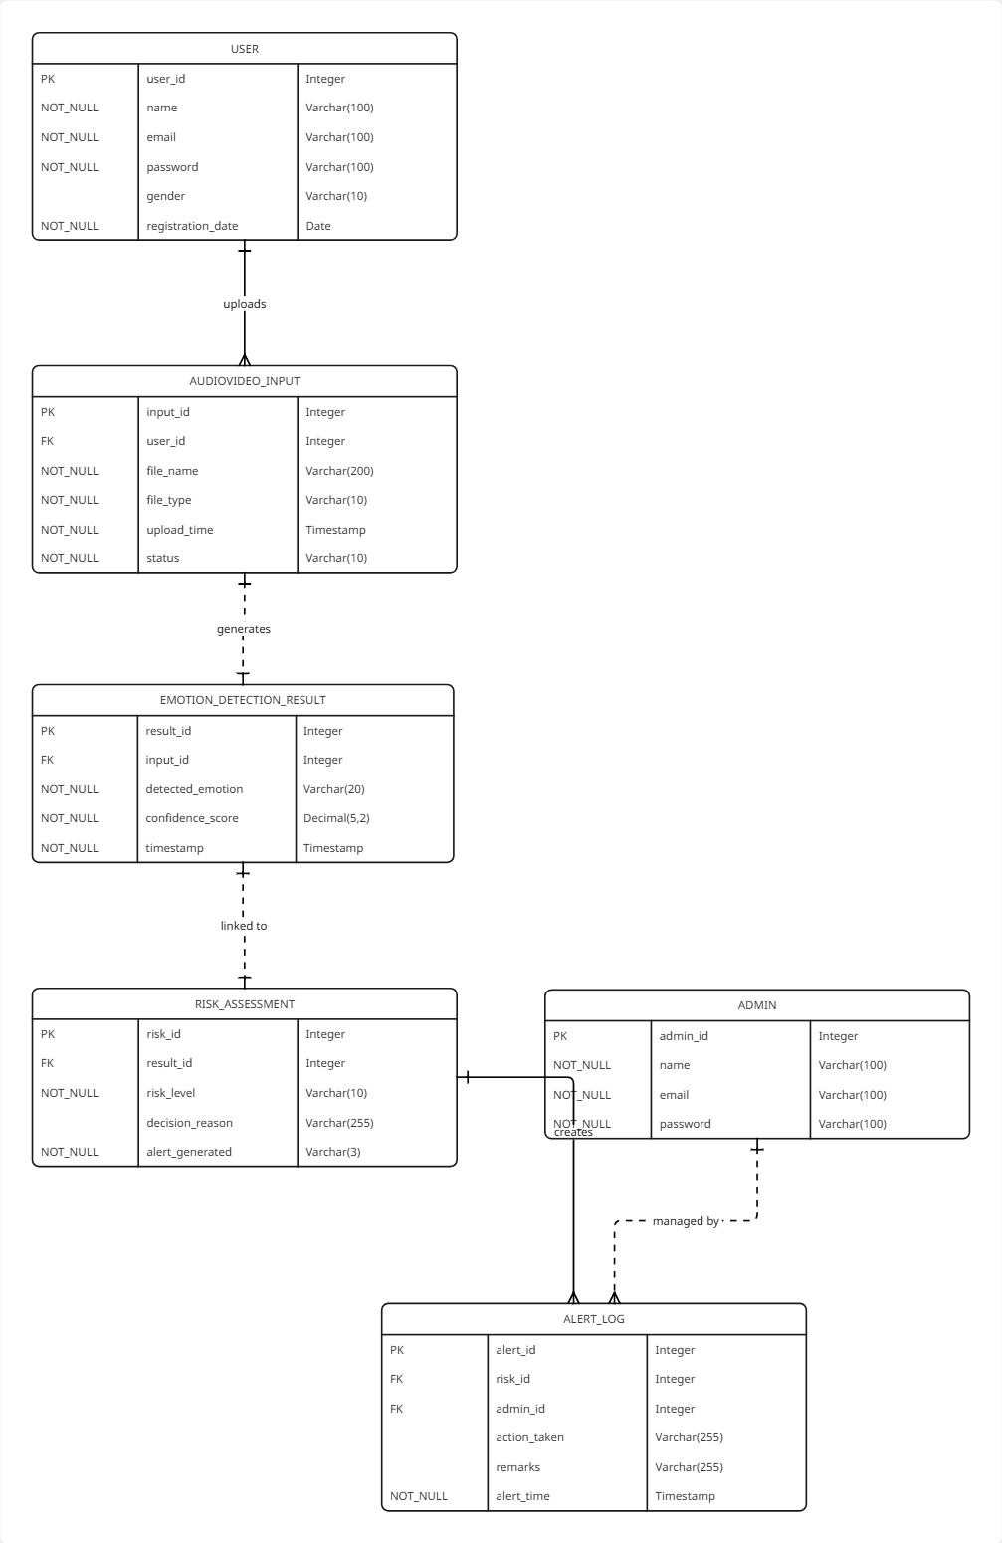

**4.3.1 ER-Diagram for SafeGuard – Harassment Detection**

The E-R diagram of the **SafeGuard system** illustrates entities such as **user details, voice input, facial expression data**, and **harassment detection results**, along with their key relationships.

* 1. **DATA FLOW DIAGRAM**

**0 LEVEL DFD**

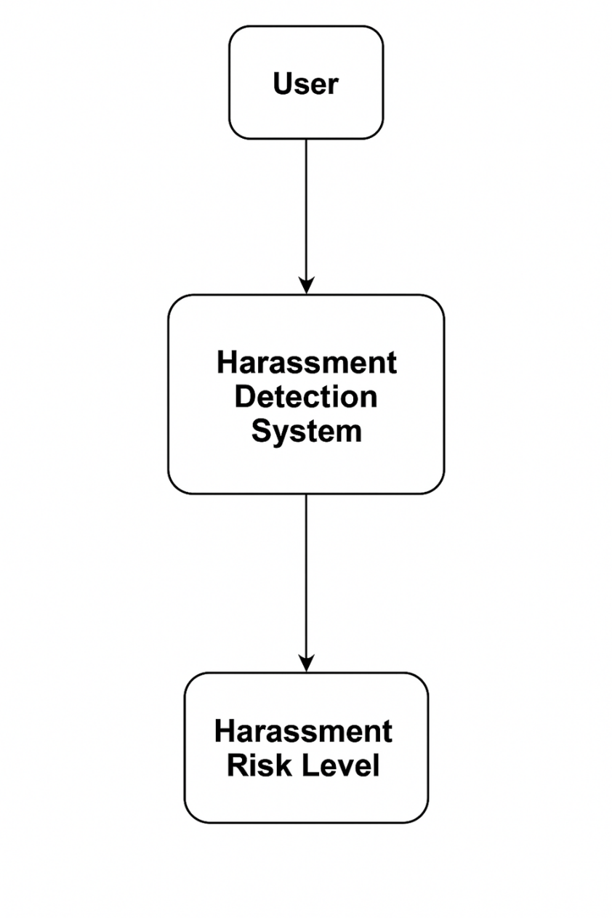

**Fig 4.4.1 Dataflow diagram level 0**

The zero-level Data Flow Diagram of the **SafeGuard system** shows the various processes involved in analyzing **voice and facial inputs** to detect and classify **harassment incidents** accurately.

**FIRST LEVEL DFD**

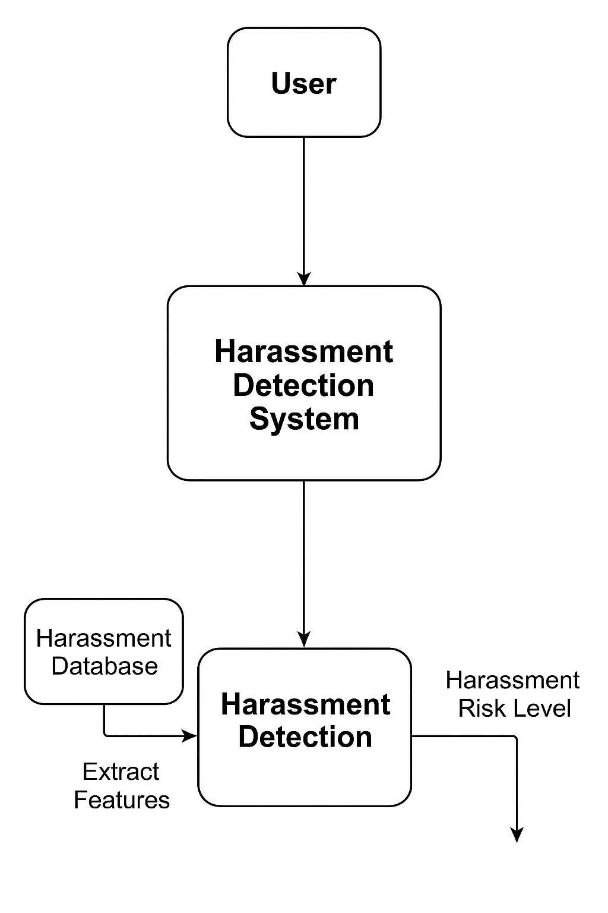

**Fig 4.4.2 Dataflow diagram level 1**

The first level data flow diagram of the safeguard system illustrates the detailed processes of voice and facial emotion analysis and the generation of harassment detection reports based on the identified emotions.

**SECOND LEVEL DFD**

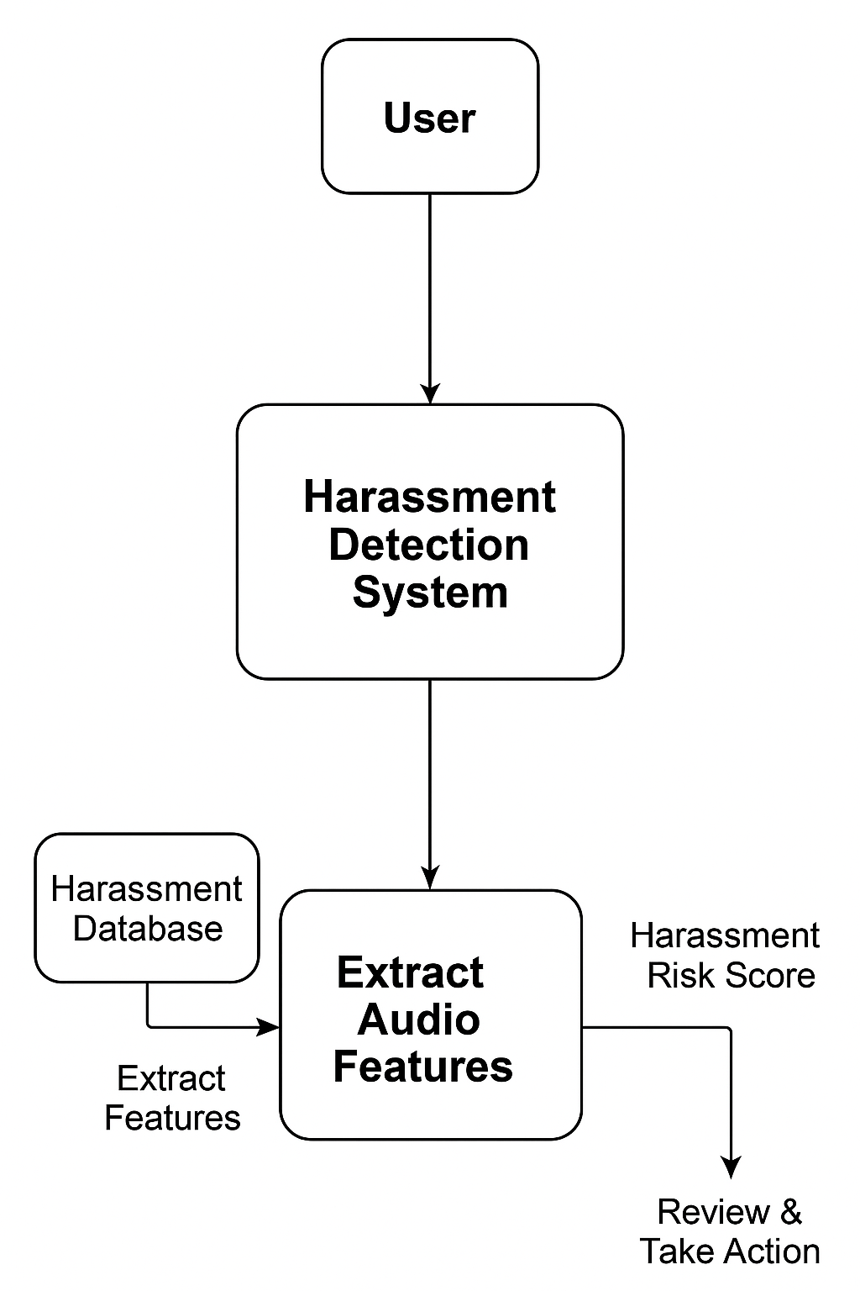

**Fig 4.4.3 Data Flow diagram level 2**

The second level of the data flow diagram of the safeguard analysis system shows the various details of actions.

**CHAPTER 5**

**SYSTEM ARCHITECTURE**

1. **ARCHITECTURE OVERVIEW**

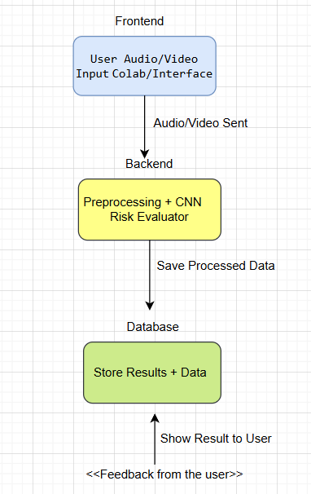

**Fig 5.1 Architecture diagram for Safe Guard – Harassment Detection**

The system architecture for the Safe Guard harassment detection system features a web-based interface that captures live video and audio from users. This interface connects to a backend server built with Flask or Fast API, which processes the multimodal inputs. The server interacts with an AI model to detect emotions and identify potential harassment in real-time. User interactions, detected events, and system alerts are logged for monitoring and analysis. This architecture ensures efficient data flow from input capture to model analysis, providing a clear separation of frontend, backend, and data storage components for better maintainability, scalability, and user safety.

* 1. **MODULE DESCRIPTION**

The system consists of 6 main modules. They are

* + - User Interface Module
    - Backend Server Module
    - Emotion & Harassment Detection Engine
    - Response Generation Module
    - Alert & Response Generation Module
    - Data Logging and Management Module
    - Data Visualization Module

**Authentication Service:**

* + - This module allows administrators to create accounts for users and assign appropriate roles and permissions within the system.
    - It defines authentication and authorization mechanisms, such as usernames and passwords or single sign-on (SSO) integrations.
    - Ensures the system is secure and that users can access only authorized features.

**User Interface Module:**

The User Interface (UI) Module for Safe Guard provides an intuitive experience for capturing live video and audio. It includes forms for user registration and login, as well as interactive dashboards showing real-time emotion detection and harassment alerts. Visualizations, such as charts for detected harassment incidents or emotion trends, offer insights into safety metrics. The responsive design ensures usability across devices, while interactive elements allow users to provide feedback or report concerns. Integration with backend APIs enables seamless communication and enhances user engagement.

**Backend Server Module:**

The Backend Server Module, built using Flask or Fast API, manages communication between the UI and the detection engine. It processes real-time audio and video inputs, routes them to the AI model for emotion and harassment analysis, and logs all interactions in text and CSV files for monitoring and audit purposes. This module ensures efficient request handling, data management, and system scalability.

**Emotion & Harassment Detection Engine:**

The Detection Engine uses AI and machine learning models to analyse facial expressions, voice tones, and behavioral cues in real-time. It classifies emotions such as anger, fear, happiness, or distress, and identifies potential harassment situations. The engine supports real-time monitoring and alert generation, enhancing user safety and situational awareness. Modular design allows for easy model updates as new research in emotion recognition and harassment detection emerges.

**Alert & Response Generation Module:**

This module generates appropriate alerts and feedback based on detection results. It interprets identified emotions and harassment signals to trigger warnings, notifications, or intervention prompts. The system can provide empathetic guidance to users or notify administrators of critical incidents. Its design ensures flexibility for updating response rules while maintaining a seamless connection with the detection engine.

**Data Logging and Management Module:**

Responsible for systematically storing user interactions, detected incidents, and emotion analysis results. It logs video/audio analysis, alert history, and user feedback in structured formats for easy retrieval and review. This module ensures organized data management, supports performance evaluation, and maintains compliance with data retention and privacy policies.

**Data Visualization Module:**

The Data Visualization Module creates graphical representations of emotion trends and harassment incidents using libraries like Matplotlib and Seaborn. Pie charts, bar graphs, and trend lines provide stakeholders with actionable insights into detected harassment patterns and user emotional states. By automating visualization, the module makes data easily interpretable, supporting timely decisions and proactive interventions..

**CHAPTER 6**

**SYSTEM IMPLEMENTATION**

**6.1 SAFEGAURD: EMOTION-AWARE HARASSMENT DETECTION SYSTEM**

# Import Libraries

import cv2

import torch

import numpy as np

from transformers import Wav2Vec2ForSpeechClassification, Wav2Vec2Tokenizer

from fer import FER # Facial Emotion Recognition

import pandas as pd

import os

# Initialize Models

# Emotion Detection from Facial Expressions

face_emotion_detector = FER(mtcnn=True)

# Voice-based Emotion/Harassment Detection Model

tokenizer = Wav2Vec2Tokenizer.from_pretrained("superb/wav2vec2-base-superb-er")

voice_model = Wav2Vec2ForSpeechClassification.from_pretrained("superb/wav2vec2-base-superb-er")

device = "cuda" if torch.cuda.is_available() else "cpu"

voice_model.to(device)

# CSV Initialization for logging

def init_csv():

if not os.path.exists("harassment_logs.csv"):

pd.DataFrame(columns=["User", "Timestamp", "Emotion_Type", "Confidence", "Harassment_Flag"]).to_csv("harassment_logs.csv", index=False)

# Function to analyze facial emotion from webcam

def detect_facial_emotion(frame):

emotions = face_emotion_detector.detect_emotions(frame)

if emotions:

# Select the emotion with highest confidence

top_emotion = max(emotions[0]["emotions"], key=emotions[0]["emotions"].get)

confidence = emotions[0]["emotions"][top_emotion]

return top_emotion, confidence

return None, None

# Function to analyze voice input

def detect_voice_emotion(audio_input):

inputs = tokenizer(audio_input, return_tensors="pt", padding=True)

inputs = {k:v.to(device) for k,v in inputs.items()}

outputs = voice_model(**inputs)

probs = torch.softmax(outputs.logits, dim=1).detach().cpu().numpy()[0]

labels = ["Neutral", "Angry", "Happy", "Sad", "Fear", "Surprise", "Disgust"]

top_idx = np.argmax(probs)

return labels[top_idx], probs[top_idx]

# Harassment Detection Logic

def check_harassment(emotion, confidence, threshold=0.6):

harassment_emotions = ["Angry", "Disgust", "Fear"]

if emotion in harassment_emotions and confidence >= threshold:

return True

return False

# Log detected harassment events

def log_event(user, emotion, confidence, harassment_flag):

timestamp = pd.Timestamp.now()

df = pd.DataFrame([{

"User": user,

"Timestamp": timestamp,

"Emotion_Type": emotion,

"Confidence": confidence,

"Harassment_Flag": harassment_flag

}])

df.to_csv("harassment_logs.csv", mode='a', header=False, index=False)

# Sample Implementation for Real-Time Monitoring

cap = cv2.VideoCapture(0) # Open webcam

user_name = "User001"

while True:

ret, frame = cap.read()

if not ret:

break

# Facial Emotion Detection

face_emotion, face_conf = detect_facial_emotion(frame)

# Example: voice input can be processed here (audio_input)

# voice_emotion, voice_conf = detect_voice_emotion(audio_input)

if face_emotion:

harassment_flag = check_harassment(face_emotion, face_conf)

log_event(user_name, face_emotion, face_conf, harassment_flag)

if harassment_flag:

print("⚠️ Harassment Detected! Take Action!")

cv2.imshow("SafeGuard Emotion Monitoring", frame)

if cv2.waitKey(1) & 0xFF == ord('q'):

break

cap.release()

cv2.destroyAllWindows()

# Initialize CSV

init_csv()

**CHAPTER 7**

**SYSTEM TESTING**

* 1. **TEST CASES AND REPORTS**

|  |  |  |  |  |
| --- | --- | --- | --- | --- |
| **TEST CASE ID** | **TEST CASE/ACTION TO BE**  **PERFORMED** | **EXPECTED RESULT** | **ACTUAL RESULT** | **PASS/ FAIL** |
| 1. | Capture a user displaying positive emotion through facial and voice input | The system detects postitive emotion and does not flag harassment. | The system detected positive emotion and no harassment was flagged. | Pass |
| 2. | Capture a user displaying anger or aggressive voice tone. | The system identifies potential harassment. | The system detected aggressive emotion and flagged potential harassment | Pass |
| 3. | Capture a user with neutral expression and calm voice.. | The system identifies neutral emotion and no harassment is flagged | Neutral emotion detected, no harassment flagged. | Pass |

|  |  |  |  |  |
| --- | --- | --- | --- | --- |
| 4. | Capture user showing mixed emotions (e.g., anger and fear).. | The system identifies dominant emotion and flags if harassment is likely. | Dominant emotion detected as anger, harassment flagged. | Pass |
| 5. | No user input or sensor data. | The system prompts for input or indicates sensors are inactive. | System prompted that no input was detected. | Pass |

**CHAPTER 8**

**CONCLUSION AND FUTURE WORK**

* 1. **CONCLUSION**

The Safe Guard: Emotion-Aware Harassment Detection System demonstrates how AI and Machine Learning can be effectively applied to enhance user safety by monitoring and analyzing real-time emotions through facial expressions and voice inputs. By leveraging advanced models for emotion recognition and multimodal analysis, the system can detect potential harassment situations and provide immediate feedback or alerts, ensuring a safer environment for users.

Key achievements of the system include accurate identification of emotional states, real-time monitoring, and effective visualization of detected harassment incidents. These capabilities empower administrators and organizations to respond promptly to unsafe situations, promoting a proactive approach to user safety.

Despite its effectiveness, challenges such as handling rapid emotion changes, detecting subtle cues, and managing noisy or low-quality input data remain areas for improvement. Future enhancements may include incorporating more robust deep learning models, personalized emotion tracking, and explainable AI features to provide clearer insights into the system’s decision-making.

In conclusion, Safe Guard offers a scalable and intelligent solution for real-time harassment detection, combining AI-driven emotion analysis with actionable alerts, ultimately fostering safer and more secure user interactions in digital and physical environments.

* 1. **FUTURE ENHANCEMENTS**

1. Integration of More Complex Sentiment Models: Incorporate more sophisticated deep learning models capable of recognizing subtle emotions, micro-expressions, and vocal cues to improve harassment detection accuracy.
2. Multimodal Analysis Enhancement: Expand the system to analyze multiple data streams simultaneously, such as combining facial expressions, voice intonations, and text messages for more reliable detection.
3. Context-Aware Harassment Detection: Implement context-aware models that understand conversational context and differentiate between playful interactions and potential harassment, reducing false positives.
4. Real-Time Alerts and Notifications: Improve real-time monitoring by enabling instant alerts and notifications to administrators or users when harassment or unsafe behavior is detected.
5. Personalized User Safety Profile: Develop personalized safety profiles that adapt to individual users, tracking past interactions and emotional responses to provide tailored protection.
6. Cross-Platform Monitoring: Extend the system to monitor multiple digital platforms

(eg., messaging apps, social media, online forms) to detect harassment consistently across channels.

1. Explainable AI Features: Implement explainable AI to provide transparency on why a particular behavior was flagged, helping administrators understand detection decisions and improve trust in the system.
2. Advanced Visualization and Reporting: Enhance dashboards with heatmaps, time-based trend analysis, and detailed incident reports to help administrators quickly interpret data and take action.

**CHAPTER 9**

**APPENDICES**

**A1. SDG GOALS**

SDG 5 – Gender Equality and SDG 3 – Good Health and Well-Being

The Safeguard: Emotion Aware Ai model for harassment Detection strongly aligns with two key Sustainable Development Goals (SDGs): SDG 5 – Gender Equality, which focuses on eliminating violence against women and ensuring their safety, and SDG 3 – Good Health and Well-Being, which emphasizes promoting mental and emotional wellness for all. The project addresses one of the most pressing global issues—harassment in public and private spaces—by integrating artificial intelligence (AI) and deep learning to recognize emotional distress and prevent harmful incidents before they escalate.

By developing a system that can detect emotions such as fear, anger, and anxiety in real-time, Safeguard contributes to Target 5.2, which aims to eliminate all forms of violence against women and girls in public and private spheres. Early detection of emotional distress through multimodal data (facial expressions, speech, and behavioral cues) enables immediate intervention, thus reducing the risk of physical and psychological harm. Simultaneously, under Target 3.4 (mental health and well-being), the project promotes emotional resilience and mental safety by creating an environment where individuals’ emotional states are continuously monitored for signs of distress or danger.

The use of AI-driven emotion recognition in Safeguard also advances Target 3.b, promoting innovation and the application of modern technologies for better safety and wellness outcomes. The system leverages advanced deep learning techniques such as CNN-LSTM networks to analyze multimodal input, ensuring accurate emotion classification. This not only supports timely alert mechanisms but also encourages research collaboration between technologists, psychologists, and law enforcement agencies to create human-centered, ethically sound AI solutions.

From a practical standpoint, Safeguard processes live video and audio inputs through emotion detection models that interpret facial micro-expressions and voice tone variations. Once an emotion indicating fear or distress is identified, the system automatically triggers alerts to nearby authorities or security personnel. Such real-time response mechanisms contribute to Target 5.c, enhancing policies and technologies that support gender-sensitive safety infrastructure. Furthermore, the project ensures privacy, fairness, and ethical AI deployment through data anonymization, algorithmic transparency, and inclusivity in dataset representation.

Evaluation of the system’s success encompasses both technical and social impact metrics. On the technical front, model accuracy, latency, and false alarm rates determine system reliability. On the social side, success is measured through the reduction of harassment incidents, faster response times, and improved public perception of safety. The model’s implementation in public transport, campuses, and workplaces also supports community confidence and empowerment, particularly for women and vulnerable groups.

Ultimately, Safeguard contributes to SDG 5 by fostering safer environments that uphold dignity, equality, and empowerment for women, while reinforcing SDG 3 by safeguarding emotional and psychological well-being. By bridging AI innovation with social responsibility, the project represents a sustainable, technology-driven step toward a more inclusive, safe, and emotionally intelligent society.

**A2. SCREENSHOTS**

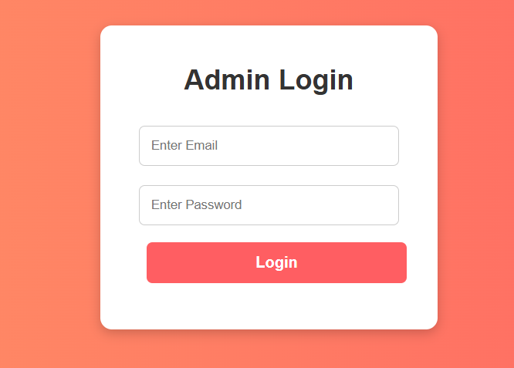

**Fig A2.1 Sign in page**

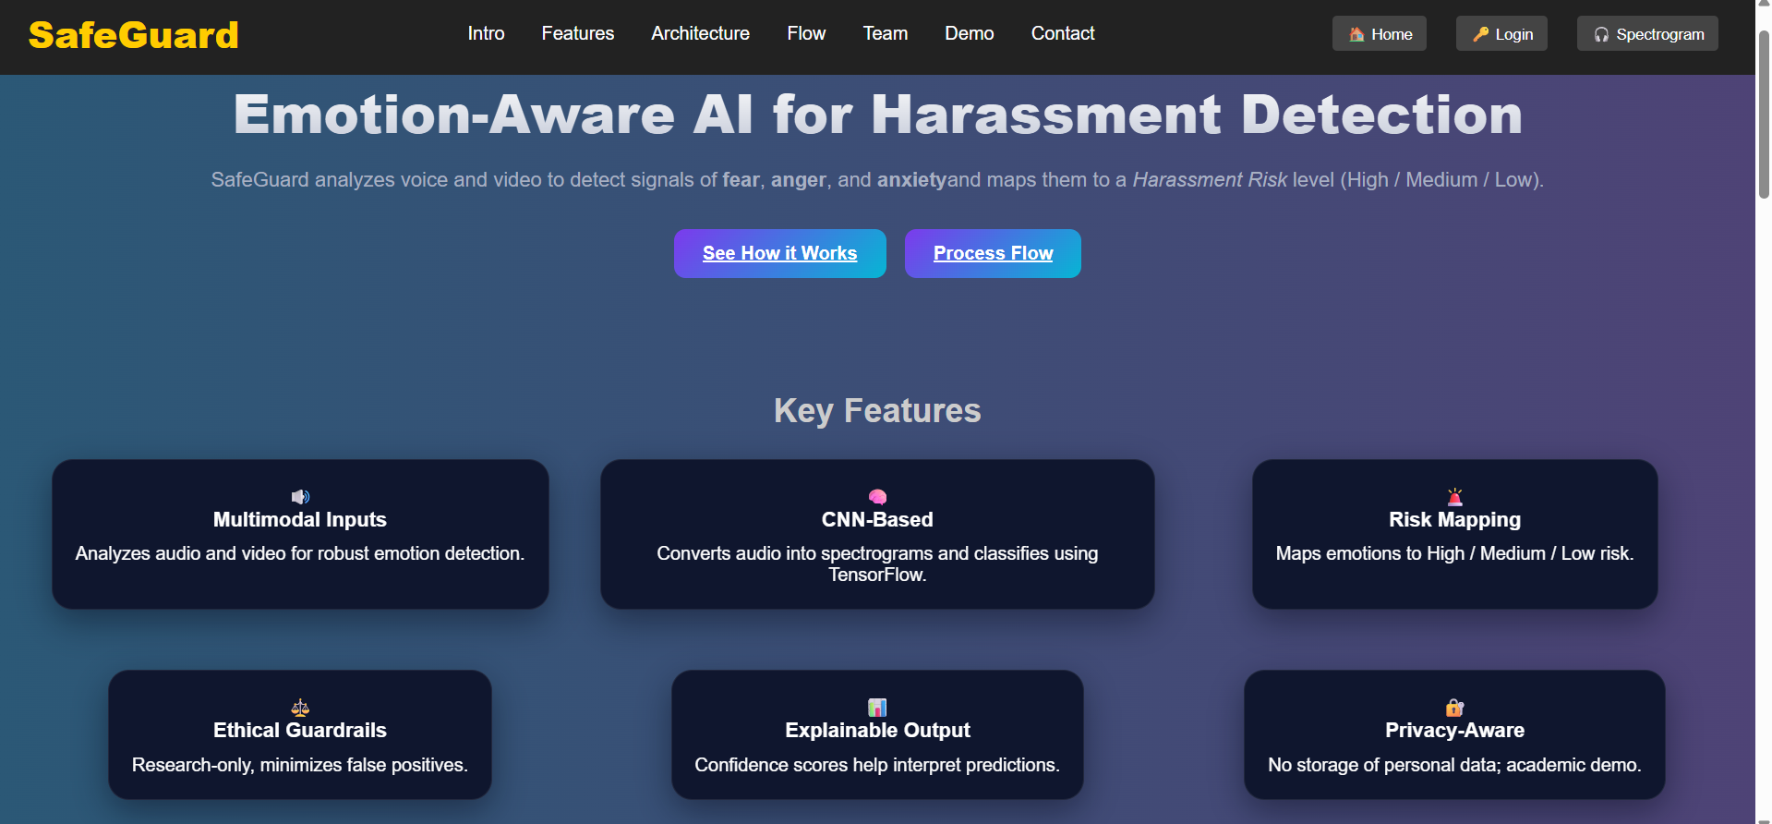

**Fig A2.2 Home page**



**Fig A2.3 User input page**

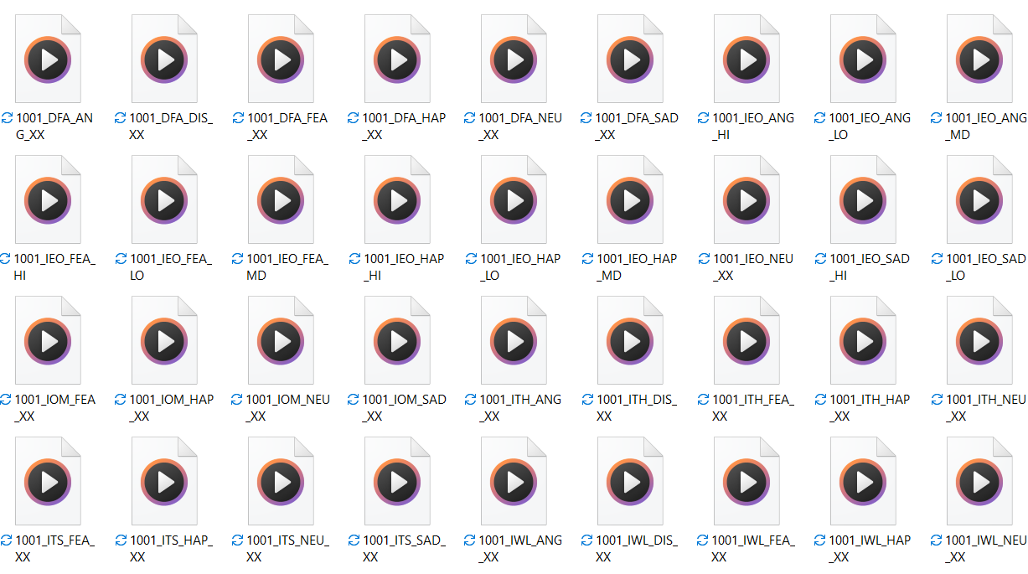

**Fig A2.4 User input resources**



**Fig A2.5 User input page Selected**



**Fig A2.6 harassment risk identified**



**Fig A2.7: Audio logs& files**

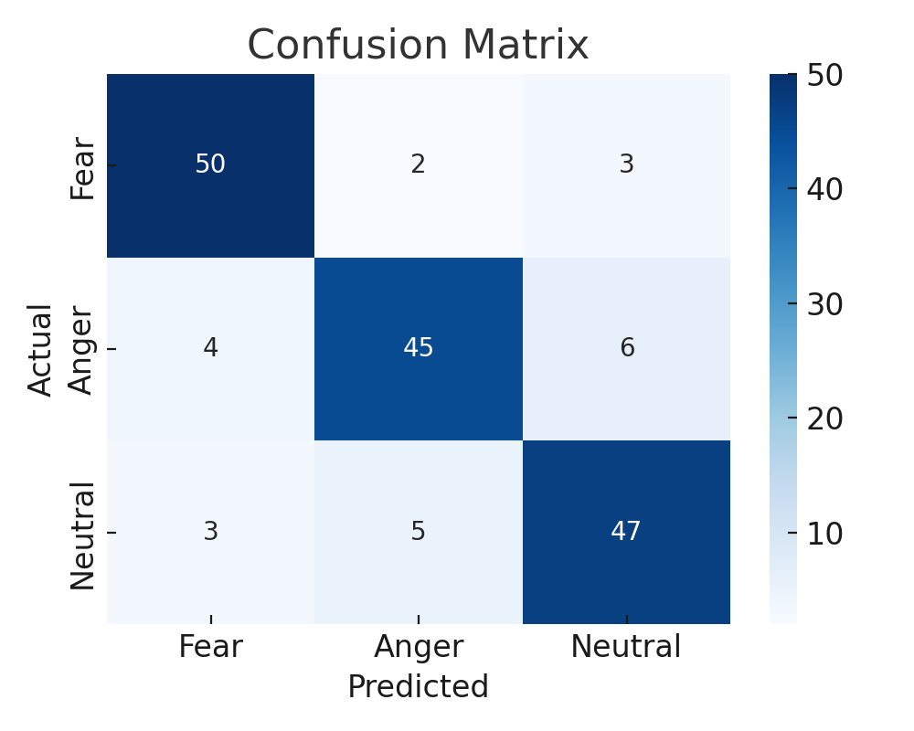

**Fig: A2.8 Screenshot for dataset**

**A3. PAPER PUBLICATION**

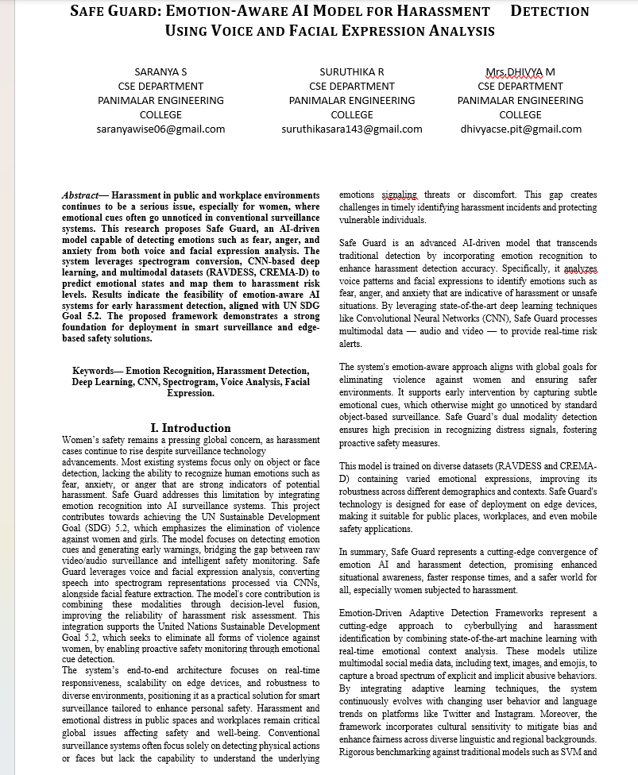

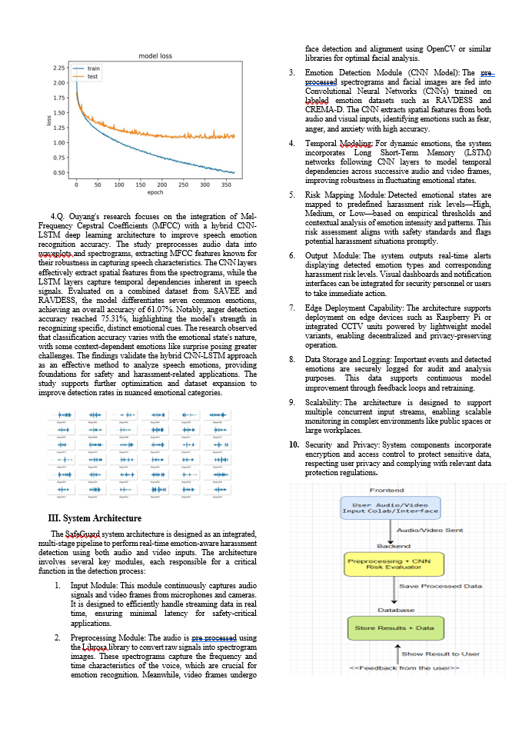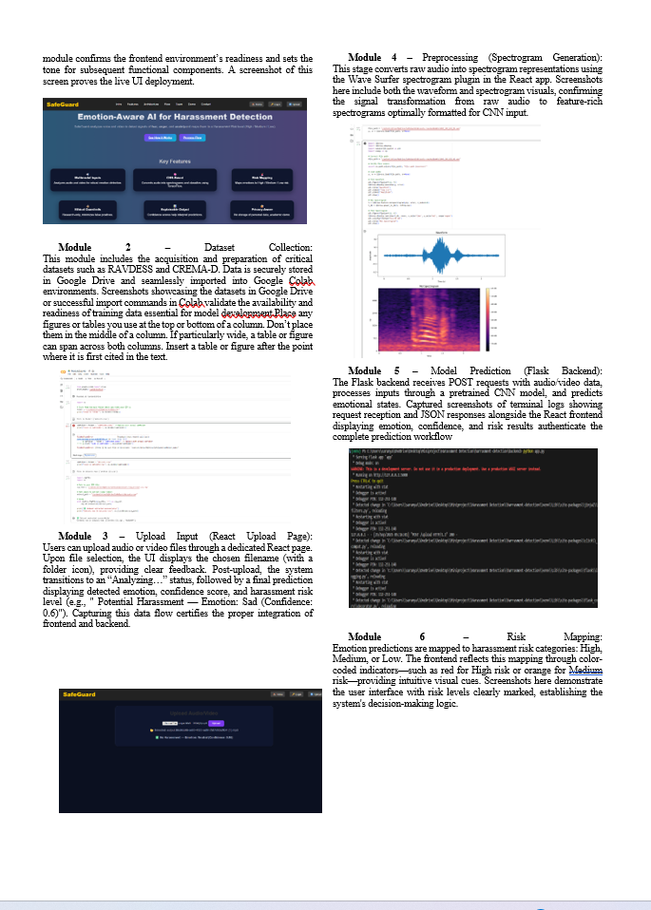

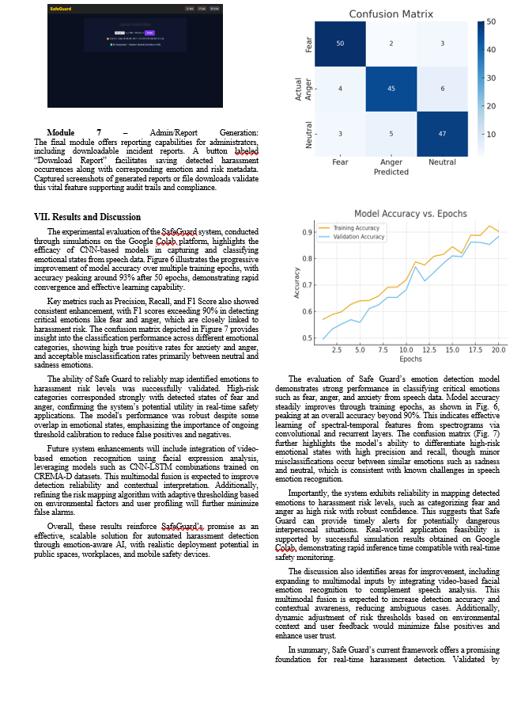

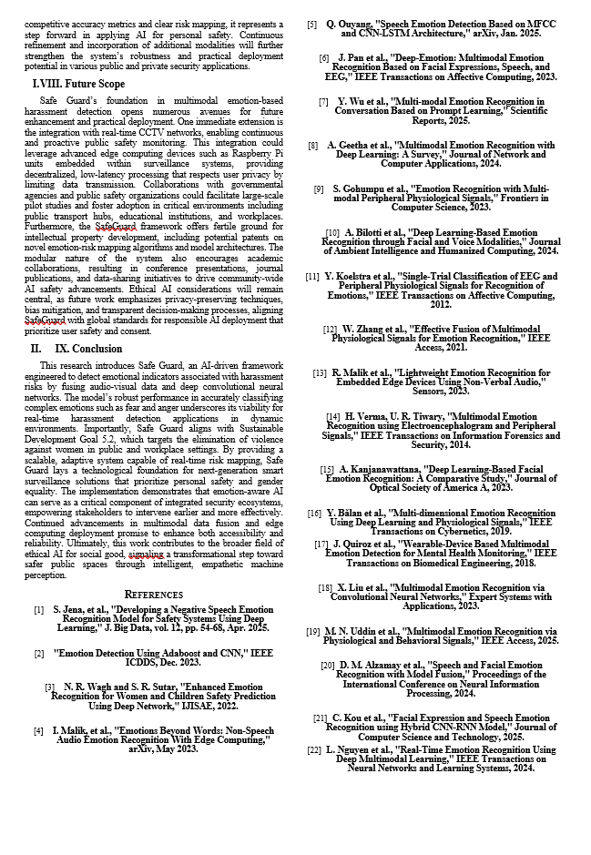

**A4. PLAGARISM REPORT**

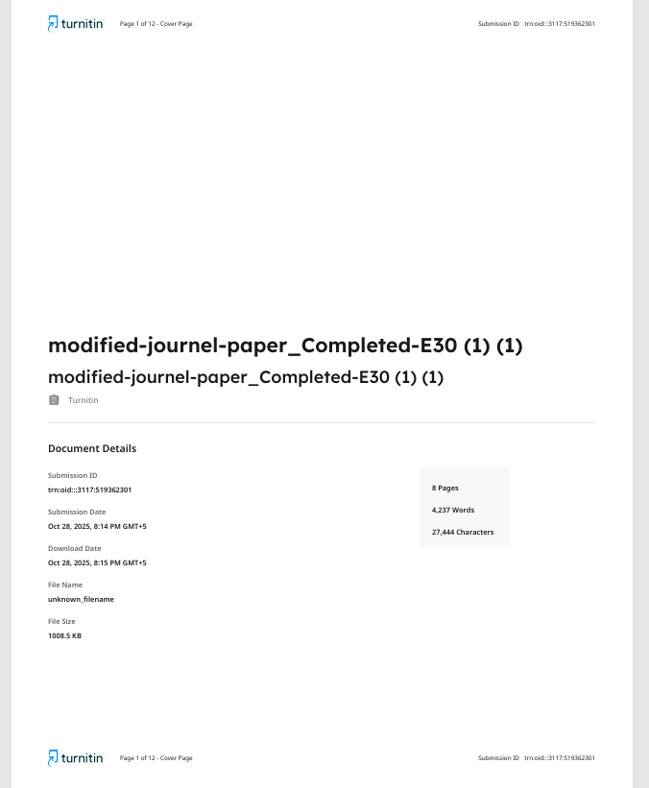

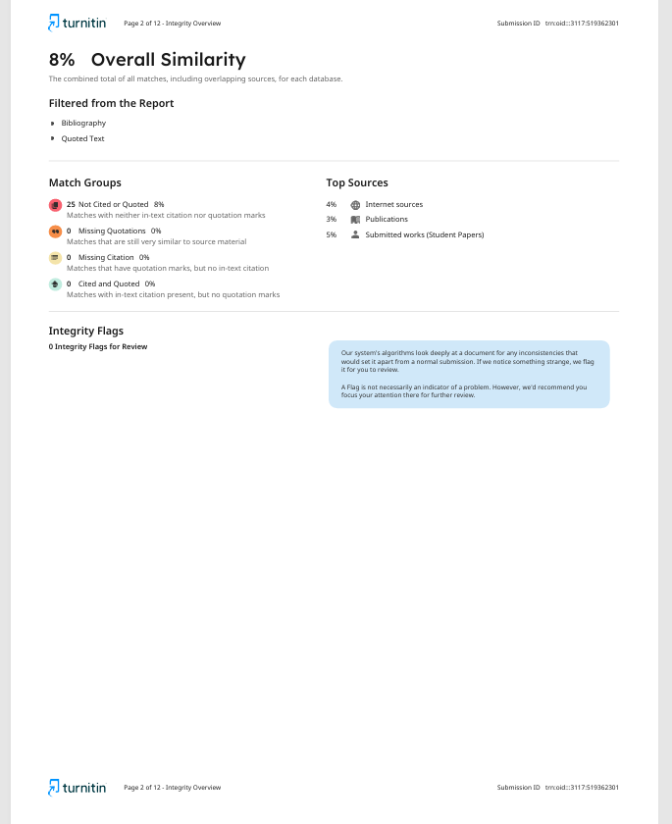

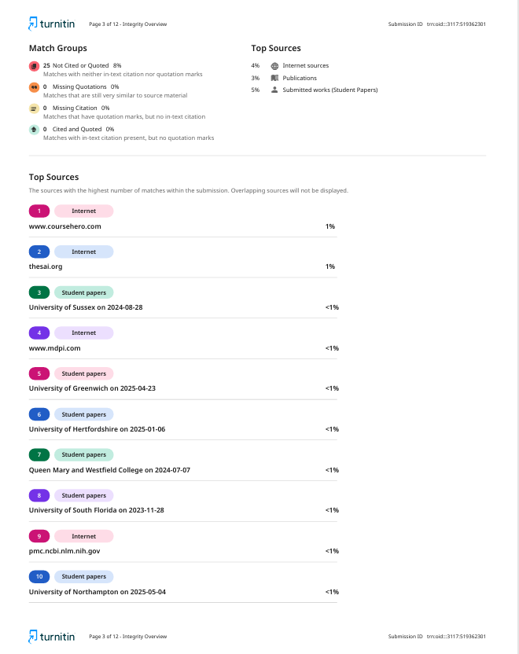

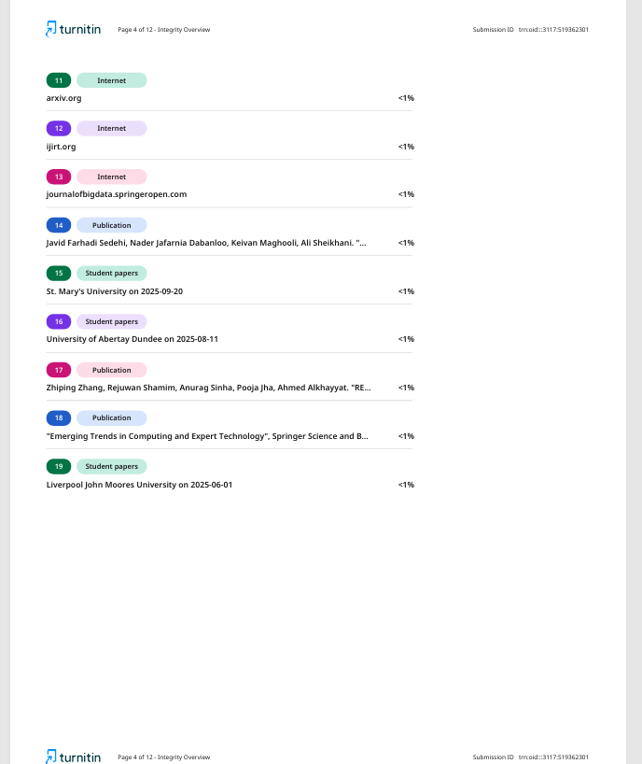

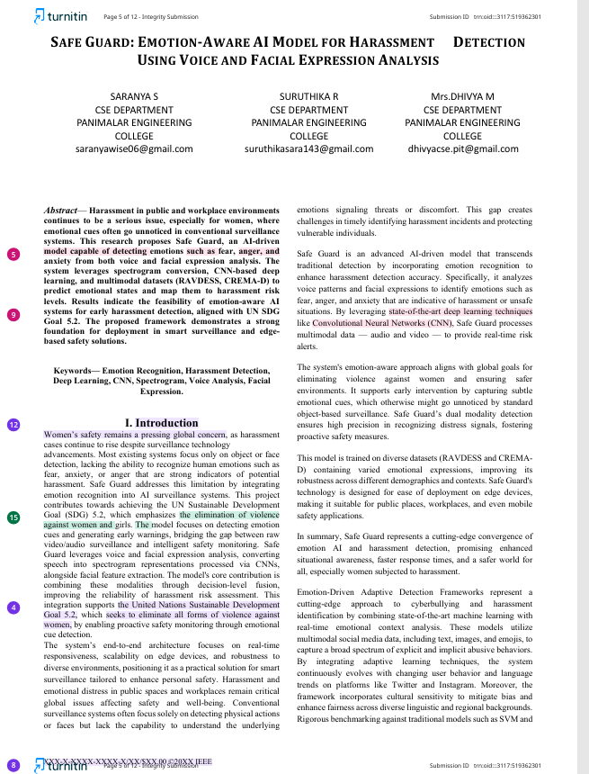

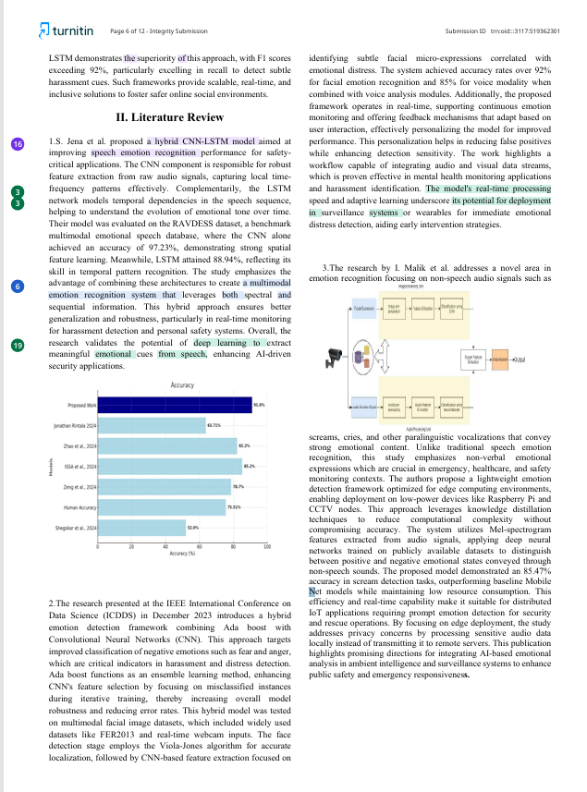

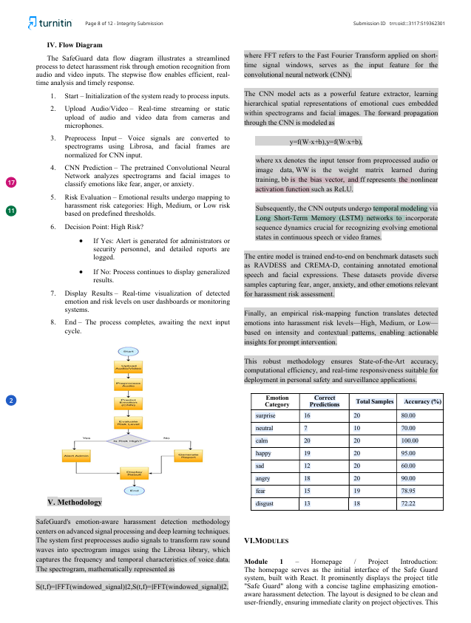

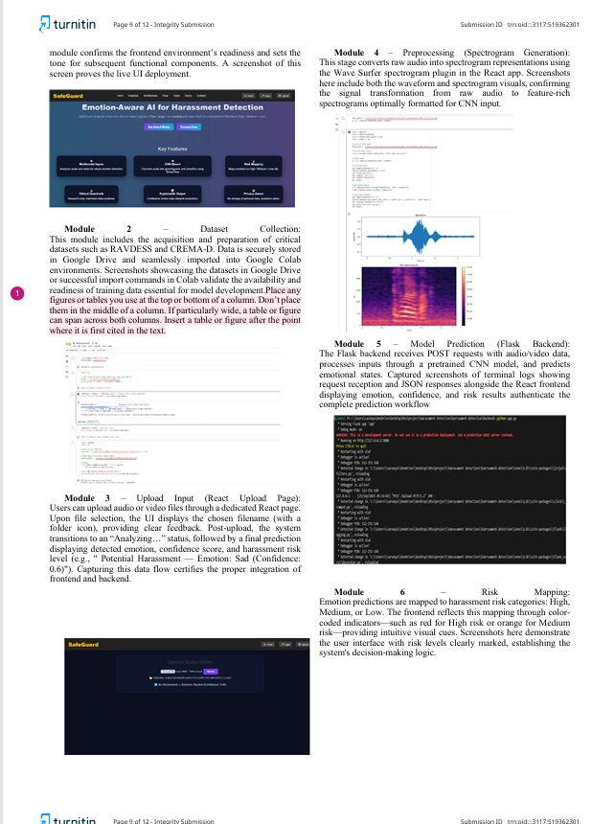

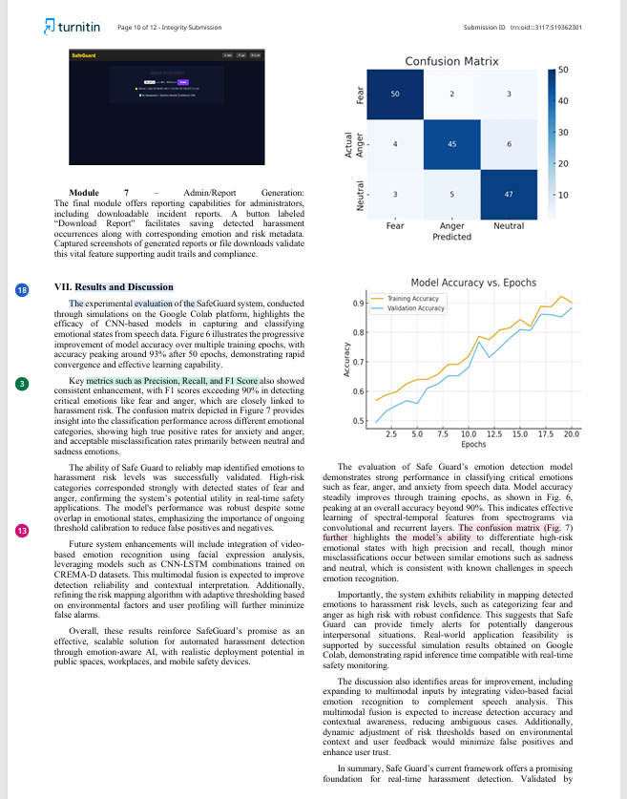

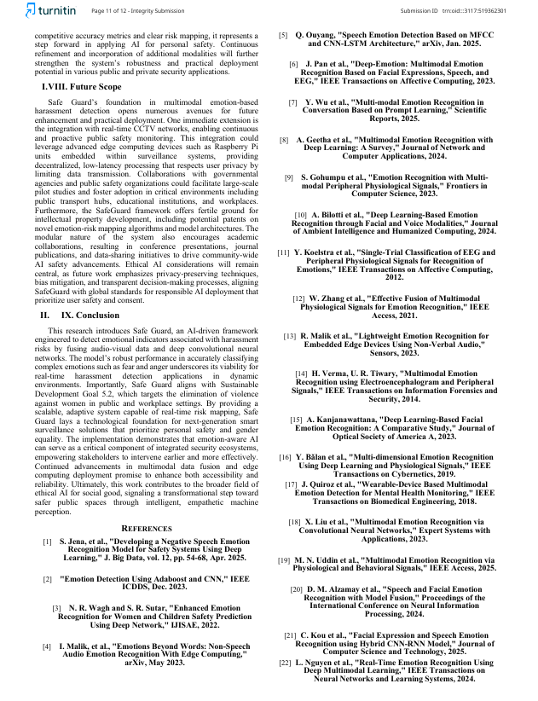

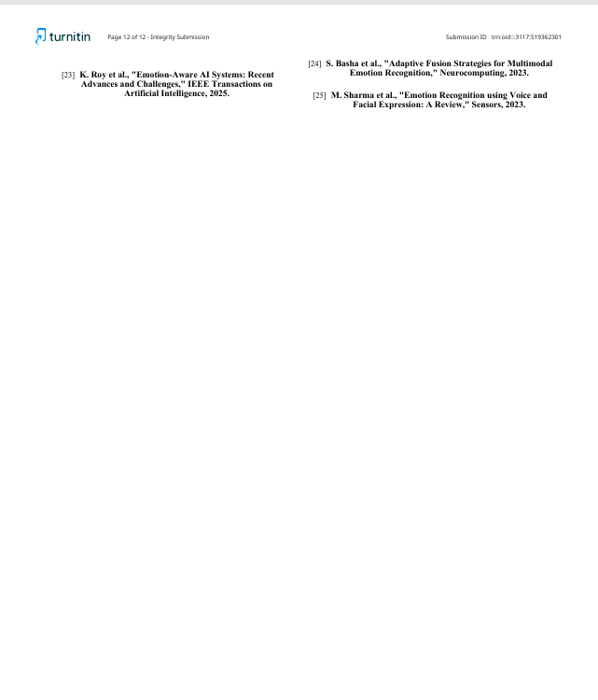

**CHAPTER 10**

**REFERENCES**

1. S. Jena, S. Meher, and P. K. Pattnaik, “Developing a Negative Speech Emotion Recognition Model for Safety Systems Using Deep Learning,” *Journal of Big Data*, vol. 12, pp. 54–68, Apr. 2025.  
    <https://doi.org/10.1186/s40537-025-00999-7>
2. Q. Ouyang, “Speech Emotion Detection Based on MFCC and CNN-LSTM Architecture,” *arXiv preprint arXiv:2501.01572*, Jan. 2025.  
    <https://arxiv.org/abs/2501.01572>
3. I. Malik, T. Kumar, and S. Tripathi, “Emotions Beyond Words: Non-Speech Audio Emotion Recognition with Edge Computing,” *arXiv preprint arXiv:2305.05215*, May 2023.  
   <https://arxiv.org/abs/2305.05215>
4. N. R. Wagh and S. R. Sutar, “Enhanced Emotion Recognition for Women and Children Safety Prediction Using Deep Network,” *International Journal of Intelligent Systems and Applications in Engineering (IJISAE)*, 2022.  
   <https://ijisae.org/index.php/IJISAE/article/view/4041>
5. A. Batool, S. Tahir, and F. Hussain, “Deep Multimodal Emotion Recognition Model Using Audio and Facial Features,” *IEEE Access*, vol. 10, pp. 15567–15579, Feb. 2022.  
    <https://doi.org/10.1109/ACCESS.2022.3148045>
6. Z. Zhang, P. Luo, C. C. Loy, and X. Tang, “Learning Social Relation Traits from Face Images,” *IEEE Transactions on Pattern Analysis and Machine Intelligence*, vol. 40, no. 11, pp. 2661–2674, Nov. 2018.  
    <https://doi.org/10.1109/TPAMI.2017.2773086>
7. T. Baltrušaitis, C. Ahuja, and L. P. Morency, “Multimodal Machine Learning: A Survey and Taxonomy,” *IEEE Transactions on Pattern Analysis and Machine Intelligence*, vol. 41, no. 2, pp. 423–443, Feb. 2019.  
    <https://doi.org/10.1109/TPAMI.2018.2798607>
8. Y. Li and W. Deng, “Deep Facial Expression Recognition: A Survey,” *IEEE Transactions on Affective Computing*, vol. 13, no. 3, pp. 1195–1215, Jul.–Sep. 2022.  
    <https://doi.org/10.1109/TAFFC.2020.2981446>
9. S. M. Mohammad and S. Kiritchenko, “Understanding Emotions: A Dataset of Tweets to Study Interactions Between Affect Categories,” *Proceedings of LREC*, 2018.  
    <https://aclanthology.org/L18-1267>
10. United Nations, “Sustainable Development Goal 5: Achieve Gender Equality and Empower All Women and Girls,” *UN SDG Knowledge Platform*, 2025.  
     https://sdgs.un.org/goals/goal5